Build a Nginx Environment

Enviroment Version
Linux version: Red Hat Enterprise Linux Server release 5.1 (Tikanga)
Linux version 2.6.18-53.el5PAE (brewbuilder@hs20-bc2-3.build.redhat.com) (gcc version 4.1.2 20070626 (Red Hat 4.1.2-14)) #1 SMP Wed Oct 10 16:48:18 EDT 2007

Installing Nginx

Obtain the installation package
nginx-1.23.2.tar.gz
Decompress the file
tar -zxvf nginx-1.23.2.tar.gz
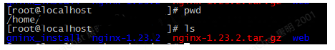

Decompress the nginx installation package
cd to the directory you just decompressed
cd nginx-1.23.2

Configure nginx software
Install at the specified location. If you want to install at the specified location, add the prefix: -- prefix
/configure --prefix=/usr/local/nginx-1.23.2
Location: /usr/local/nginx-1.23.2
Default installation location
./configure
Location: /usr/local/nginx

Compile and install
make && make install

View the installation
whereis nginx
Some will not have content
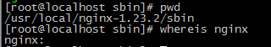

Start nginx
Go to /usr/local/nginx-1.23.2/sbin
./nginx

Check whether the startup is successful
ps -ef | grep nginx

nginx command
In the /usr/local/nginx-1.23.2/sbin directory
Start: ./nginx
Stop: ./nginx -s stop
restart: ./nginx -s reload

Configure nginx.conf
For the information to be modified, see the following part in red
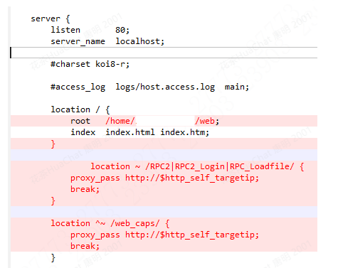
Path: /usr/local/nginx-1.23.2/conf/ nginx.conf

See the following file:
If you cannot access it, the reason is that port 80 of your server firewall is not open. You can change port 80.
# View the service ports that are open
firewall-cmd --list-all
# Open port number command
firewall-cmd --add-port=xxxx/tcp –permanent
# Restart the firewall for the configuration to take effect
systemctl restart firewalld.service

Configure HTTPS Access for Nginx

Check whether the SSL module is supported
/nginx –V
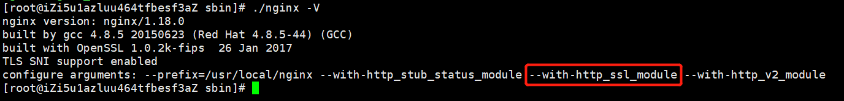
If you see configure arguments: --with-http_ssl_module, it means it has been installed. If not, click the link (https://blog.csdn.net/zhang_130914036/article/details/126096067) to see how to install it.

Certificate deployment
Download the requested ssl certificate compressed package to your local computer and decompress it (pem and key files are used here. You can change the file name as needed).
Create cert folder in the nginx directory to store the certificate file.
cd /usr/local/nginx-1.23.2
mkdir cert
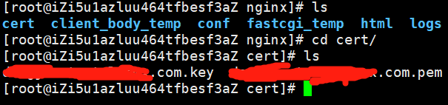

nginx.conf configuration
Edit /usr/local/nginx-1.23.2/conf/nginx.conf configuration file.
Add https server.
server {
listen 443 ssl;
server_name www.teruisa.com;

ssl_certificate ../cert/www.teruisa.com.pem;
ssl_certificate_key ../cert/www.teruisa.com.key;

ssl_session_cache shared:SSL:1m;
ssl_session_timeout 10m;
ssl_prefer_server_ciphers on;
ssl_ciphers ECDHE-ECDSA-AES128-GCM-SHA256:ECDHE-RSA-AES128-GCM-SHA256:ECDHE-ECDSA-AES256-GCM-SHA384:ECDHE-RSA-AES256-GCM-SHA384:ECDHE-ECDSA-CHACHA20-POLY1305:ECDHE-RSA-CHACHA20-POLY1305:DHE-RSA-AES128-GCM-SHA256:DHE-RSA-AES256-GCM-SHA384;
ssl_protocols TLSv1 TLSv1.1 TLSv1.2;

location / {
root /root/web;
index index.html index.htm;
}
location ~ /RPC2|RPC2_Login|RPC_Loadfile/ {
proxy_pass http://$http_self_targetip;
break;
}
location ^~ /web_caps/ {
proxy_pass http://$http_self_targetip;
break;
}
}
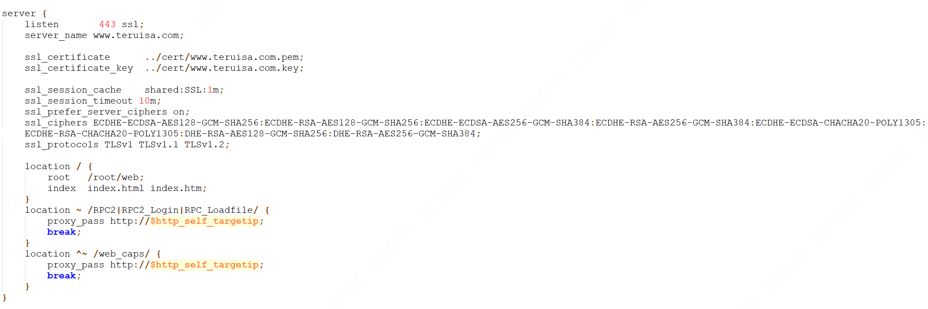

Configure HTTP access to automatically jump to https
Note: If you want both http and https access, you do not need to configure it.
Edit /usr/local/nginx-1.23.2/conf/nginx.conf configuration file.
Edit the http server on port 80 of the original listening configuration, and adjust it as follows:
server {
listen 80;
server_name www.teruisa.com;
# Convert the request to https
rewrite ^(.*)$ https://$host$1 permanent;
}
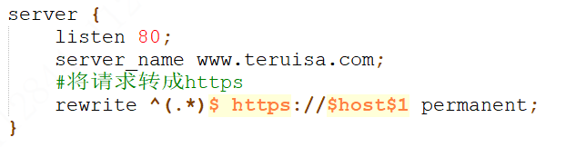

Web SDK Access

Web demo configuration
The actual web demo file is placed in the specified directory, as shown in the preceding configuration address. The two must be consistent.
/home/test /web

Web browser access
